

**FROST HACK 2021**

**Patients health monitoring system using WEARABLE IOT TECHNOLOGY**

By:

TEAM AZTEC

Department of ECE

Bannari Amman Institute of Technology

Tamil Nadu

**Our Team:**

Team_Aztec

|  |  |  |
| --- | --- | --- |
| **Name** | **E-Mail** | **Phone** |
| Abilash G (Team Leader) | abilash.ec19@bitsathy.ac.in | 7598336901 |
| Gowthamraj D R P | gowthamraj.ec19@bitsathy.ac.in | 9487424631 |
| Jayasurya J | jayasurya.cs19@bitsathy.ac.in | 9445199191 |

**Project Name:**

Patient Health Monitoring System using Wearable IoT technology.

**Theme:**

Healthcare and Medicine.

**Problem and Solution:**

In this pandemic situation, many people could not be able to stay with their diseased or physically challenged parents or relatives. Moreover, even during regular days, we are unable to stay with our parents, who are not well. Many unpredictable accidents are happening when we leave them alone. It is not possible to take care of them all the time. To reduce the stress and the tension among humans, we have planned a patient monitoring system. There are lots of people who stay abroad, leaving their parents alone. In such emergencies, our patient monitoring system will help in earlier intimations, and hence it reduces the critical situations. There may be an unexpected situation such as an increase in sugar level, an increase or decrease in pressure level, and a pandemic situation that we never expect. Our system will help in monitoring the patients and helps in the earlier intimation to necessary people like calling an ambulance or the doctor who can be set manually by the caretaker or the guardian. So not only during this pandemic situation and also during regular days, our system helps humans effectively. Hence the death rate can be reduced eventually. By this system, mentally, the guardians or the caretaker can be stress-free.

**Technologies used:**

1. **IoT**
2. **Amazon API Gateway** is used to build the app for the device.
3. **Amazon Simple Storage service** is used to store the data gathered from the device.
4. **AWS Lambda** is used to compute the code function for the whole device to perform.

**Video Presentation:**

<https://youtu.be/D1SFEhoxcfg>

**PROPOSED SOLUTION:**

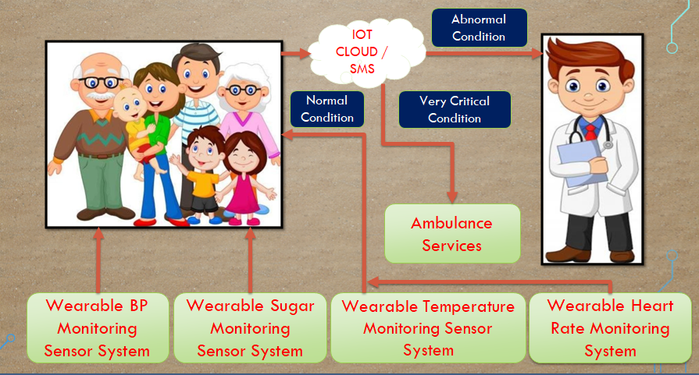

**WORKING OF THE DEVICE:**

The device has the capability to check the temperature, sugar level, heart rate and BP and data's will send to the cloud, in cloud it will be compared with database and will process the following activity

There are three major cases in this project

Case (1): If the temperature, sugar level, heart rate and BP are normal

The device will return the value to the patient.

Case (2): If anyone of the value is abnormal

The device will send the message to the doctor and the patient will receive prescription from the doctor.

Case (3): If anyone of the value is very critical

The device will automatically call the ambulance. This services will be helpful for old patients who living alone.

**NORMAL TEMPERATURE AND SUGAR LEVELS:**

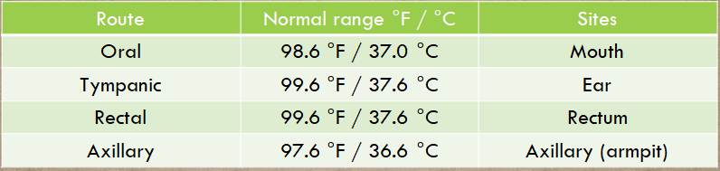

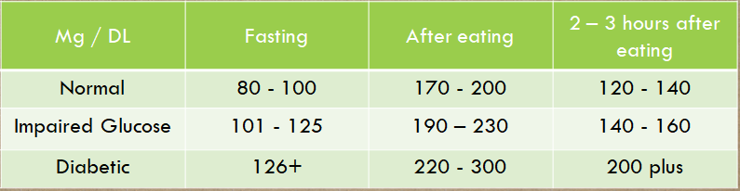

**NORMAL HEART RATE VALUES:**

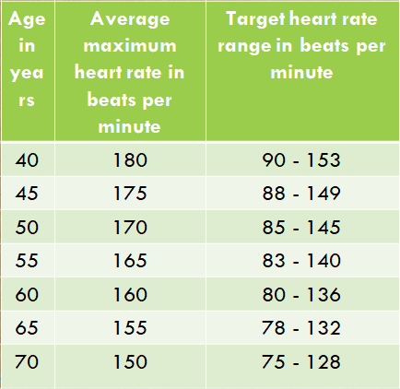

**BLOOD PRESSURE RANGE:**

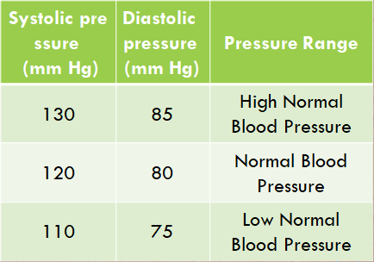

**CUSTOMER / MARKET ANALYSIS:**

The benefits attained by the customer are listed below

* The patients who do not have proper bus facilities to go to hospital for periodical testing (i.e. Sugar patients) can benefit through this project.
* Our Product has the facility to report to the doctor if anything is abnormal.
* Our Product has the emergency ambulance services will be helpful for old patients who living alone.
* Due to COVID-19 old age persons, pregnant women and children with heart problem wouldn’t be able to go outside, but they would periodically monitor their health, this product will help them a lot.